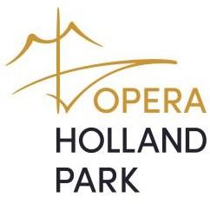
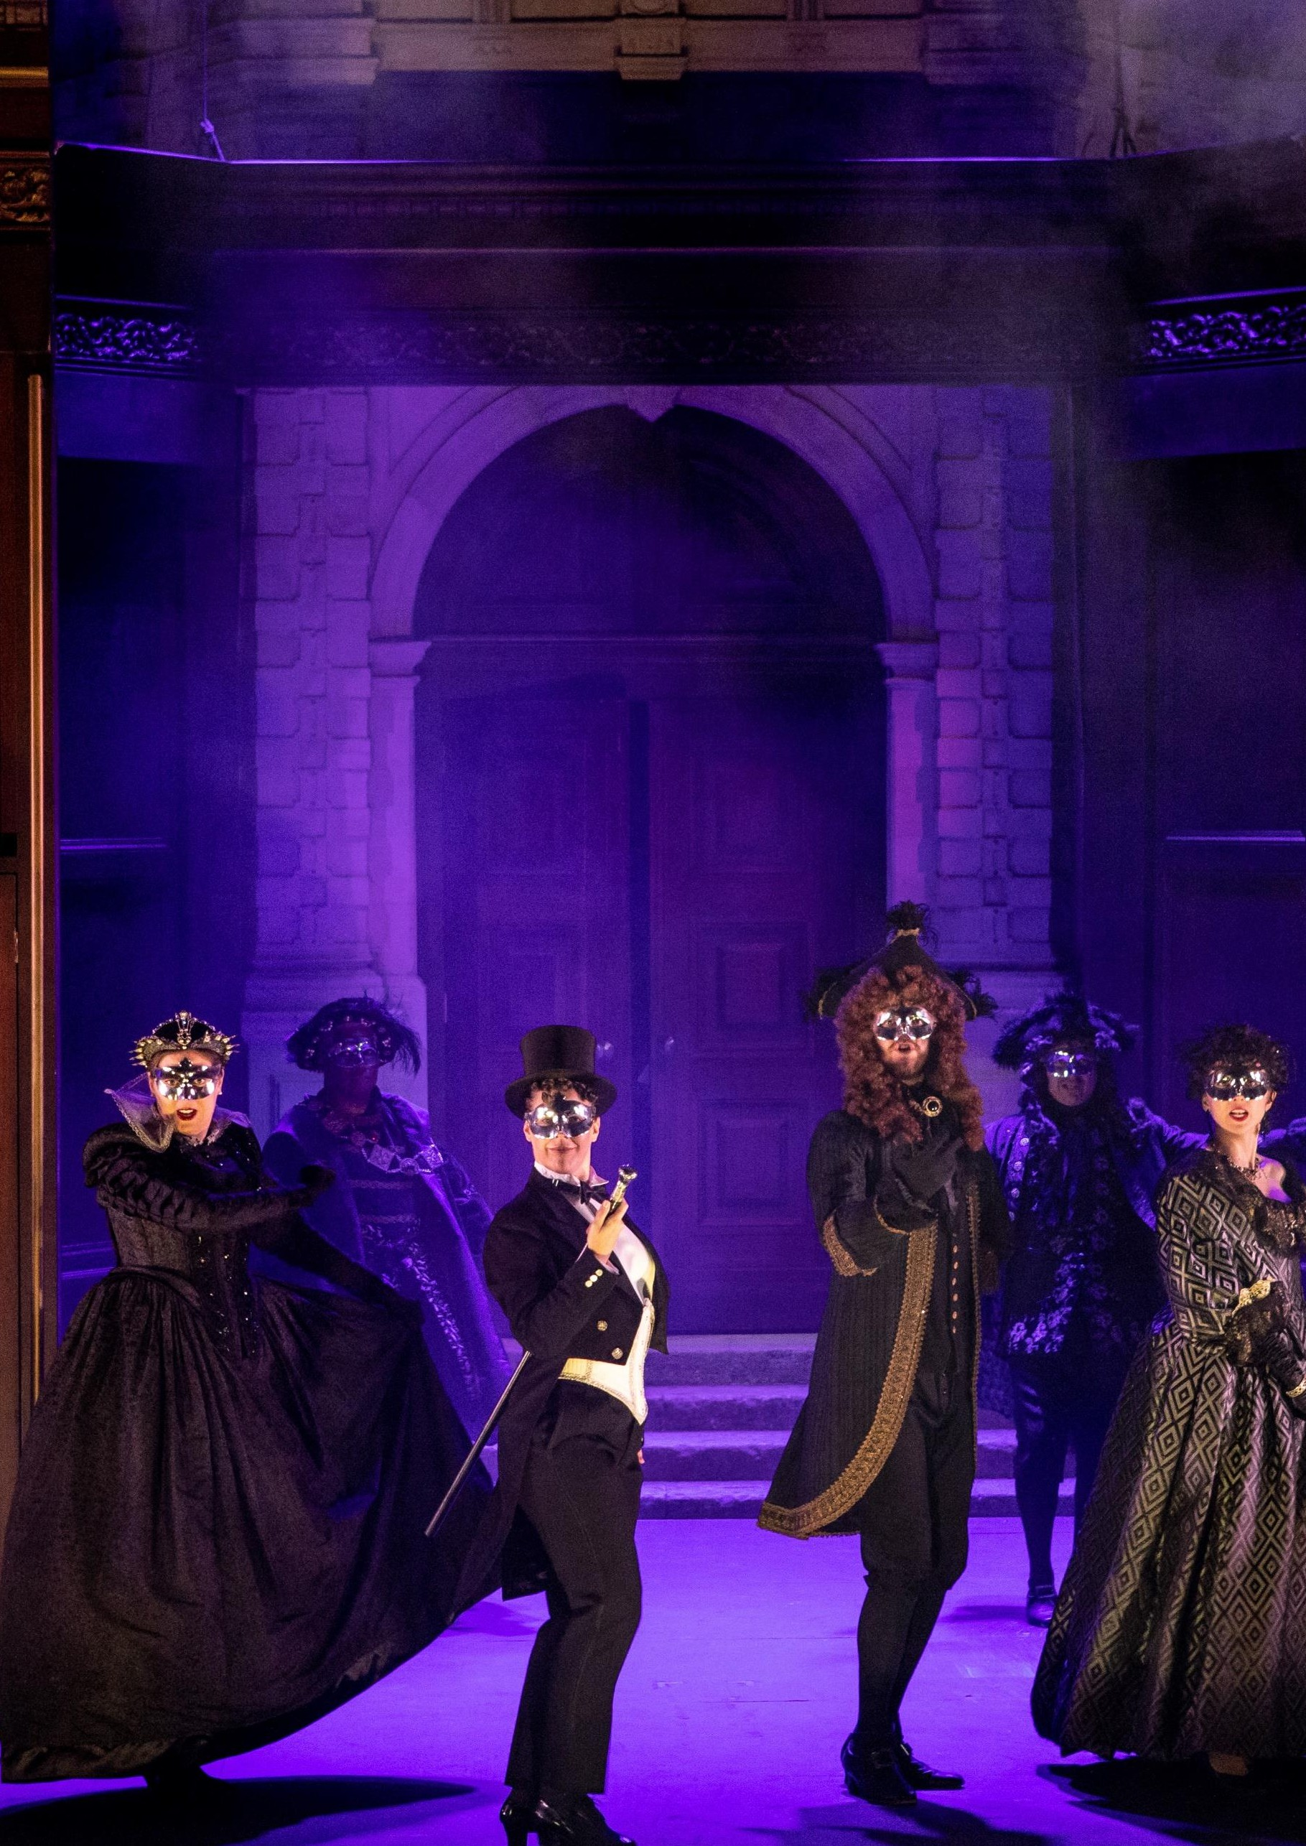

Opera Holland Park www.operahollandpark.com

Opera Holland Park Job Application Pack

Opera Holland Park Job Application Pack

We are Opera Holland Park
We are an urban company in a leafy, airy setting. Every summer we build a theatre and perform to audiences from the Royal Borough of Kensington and Chelsea and beyond.
We identify and nurture emerging talent through our Young Artists scheme, and welcome singers, conductors, directors and designers back as their careers take flight.
We are an independent charity. Throughout the year, we serve the community in care homes, hospices, shelters and schools. We build the audiences of the future and take music to those for whom a traditional theatre setting is inaccessible.
We work in a 400-year-old multimedia live art form and tell stories through the expressivity and emotional honesty of the unamplified human voice. Our work covers a multitude of genres, time-periods and places. We take our audiences with us, introducing them to rarities and celebrating well-loved classics together.

Cover image: Alison Langer (Oscar) and members of the Opera Holland Park Chorus in Verdi’s Un ballo in maschera © Ali Wright, 2019

Our Mission and Values
Our mission is to share the cultural, wellbeing and social benefits of opera with our local community in Kensington & Chelsea and beyond. We do this by:
- Staging affordable and accessible, high-quality opera productions at our open air theatre in the centre of Holland Park
- Working with our family of freelance performers and creatives to bring opera to those for whom traditional theatre productions are inaccessible
- Providing opportunities for emerging talent in the opera industry to develop their skills and gain experience in a supportive environment
- Using our platform as a respected arts organisation to dispel stereotypes and spread the message that opera is for everyone
As a company and a community, we work together to make sure everything we do embodies our values:
- Creativity – Whether we’re producing our summer opera festival, building our theatre in the heart of Holland Park, or looking for ways to make opera accessible to new audiences, creativity is central to our work.
- Community – Opera Holland Park is not just a company but a community, made up of all the people who support us, work with us, see our shows and take part in our events and workshops. Through our outreach and education work, we aim to welcome as many people as possible from the local community into the Opera Holland Park family.
- Integrity – We are a company with integrity. Every one of us believes wholeheartedly in the importance of each project we work on. When it comes to our productions, we strive to get to the heart of the stories that make opera such a compelling art form.
- Respect – As a company and a community, our respect for one another defines how we work together in the rehearsal room, offices, backstage and beyond. It also defines our relationship with the historic site where our theatre is based, and our approach to the environment and sustainability.
- Passion – What unites us as a community is our passion for opera, for the cultural, wellbeing and social benefits classical music can offer, and for showing that this profoundly human, 420-year-old art form is for everyone and is still relevant today.

Job Description
Department/Team: Customer Experience Team
Contract type: Fixed-term contract from May 2026 to August 2026.
Starting 9 March 2026 for 8 weeks, part-time, followed by full-time for 15 weeks from 4 May 2026 until 14 August 2026.
Location: Opera Holland Park Theatre, Holland Park, Ilchester Place, W8 6LU, London
Probation period: 2 weeks Notice period: 1 month
Hours: 40 hours a week with evening and weekend work to be expected. The role will be supported by a deputy, and shifts will be negotiated between these roles.
Salary: £35,000 per rata dependent on experience.
Apply by: Wednesday 11 February 2026 at 5pm
Duration of the festival: 26 May-8 August 2026.

Purpose of job
The Front of House Manager is responsible for ensuring all audiences at Opera Holland Park have an excellent customer experience. The primary objective of the role is to welcome customers, paying attention at all times to their needs and dealing with issues as they arise in an efficient and calm manner.
The successful applicant will also work alongside the Site Manager and the Bar and Hospitality Manager to ensure a healthy, safe and secure environment for audiences at the theatre.

Day in the life
Every day looks a little bit different, but a typical day might include arriving at the theatre before the Front of House team arrive to liaise with the Bar & Hospitality Manager about specific events and functions on that day, and the Head of Ticketing and Customer Insights about any specific customer requirements. You will then lead a Front of House team meeting before shifts start and customers start arriving on site. You will be responsible for ensuring that the site is ready to open on time, and give clearance with the Site Manager and production team to give clearance for the performance to start. Throughout the performance, you will be managing your team

with enquiries, ensuring excellent customer service, scheduling Front of House announcements and working with the Site Manager to ensure the site looks presentable at all times. After the performance has finished, you will ensure the safe exit of customers from the theatre, and complete a show report to distribute to the wider team.

Practicalities, role expectations and accessibility
The Front of House Manager position will be based at the Opera Holland Park Theatre, which is in the middle of Holland Park, and is mostly canopied. They can expect to be exposed to the elements for the duration of the festival season, from extreme heat, to the cold and wet.
The role will require a lot of standing and walking during each shift.
The role requires a positive attitude, confidence, and a high degree of diplomacy. As it is public facing, unexpected situations will arise regularly, and no day is the same.
Access to the theatre site is step-free via both the East and West Gates. There is a short hill with a steep gradient at the West Gate, so the East Gate is more appropriate for those using a self-propelled wheelchair.

Role outline
Customer service
- Promote and ensure the highest standards of customer service in the team
- Complete show reports after each performance, distribute to colleagues and ensure that any issues that were highlighted during the shift are immediately being dealt with by colleagues
- Deal with customer feedback and provide solutions to customer complaints, working with the administration team where necessary

Team management
- Assist in the recruitment of Front of House stewards for the theatre, coordinate interviews and lead training
- Manage and supervise the team of Front of House stewards to ensure highest levels of customer service to audiences and donors at all times

- Create and distribute weekly rotas for the Front of House team, ensuring punctuality and reliability across the department
- Ensure that the Front of House team is fully up to date with information about performances and memberships at Opera Holland Park, as well as important stakeholders, donors or audiences with access requirements
- Create a positive work environment for staff; encouraging career development and opps.
- Monitor staffing levels and adjust shift patterns throughout the month as needed to ensure sufficient coverage and financial efficiency

Health and Safety
- To act as a decision maker with regard to any issues of Health and Safety in coordination with the Site Manager
- Take the lead in the event of any evacuation or security situation in coordination with the Site Manager
- Arrange health and safety, First Aid training and customer service training to Front of House stewards

General
- Support colleagues, managers and audiences in all aspects of health and safety, emergency and evacuation procedures as required
- Ensure that the front of house space and the auditorium is always well presented. Be proactive and reactive in making improvements
- Work with the Site Manager and Chief Electrician to set up, schedule and operate Front of House announcements
- Work with the Head of Ticketing and Customer Insights to set up customer information reports, ensuring all customer information is communicated to relevant member of the team and distributed to Front of House stewards according to data protection policies
- Coordinate staff uniforms

The duties and responsibilities outlined in this job profile are indicative of the role; however, they are not exhaustive and may be subject to change. In addition, you will be required to undertake other reasonable duties as directed by your manager.

Person Specification

Essential criteria
- Front of House experience, preferably within a theatre environment or an arts organisation
- Excellent leadership skills
- Excellent customer service
- Patience and ability to remain calm, positive and professional when working under pressure
- Ability to be creative and resourceful in problem solving
- Ability to work well under pressure
- Excellent verbal communication
- Budgeting experience
- Collaborative approach

Desirable criteria
- Experience of managing or supervising staff
- First Aid/Emergency First Aid, Fire Marshal Training
- Knowledge of Opera Holland Park and the performing arts industry
- Experience using Spektrix

How to apply
To apply for this role, please:
- Download the Application Form here (also available in large print)
- Complete the anonymous Equal Opportunities Monitoring Survey here.
- Complete the Application Form, and email it as an attachment (either in Word or PDF format) to info@operahollandpark.com. Please make sure you demonstrate how your skills and experience meet the person specification provided. There are some tips in the form to give you guidance on how best to do this.
- We also accept applications in video or audio format. If you would prefer to apply in this way, please email a link to your video to the email address provided. As a guideline, you should aim for a recording of around 5 minutes, and you should answer all the questions on the Application Form
We will be accepting applications until Wednesday 11 February at 5pm. Any application received after this may not be included in the recruitment process.
We aim to reply to all applicants with the outcome of their application within two weeks of the deadline. We will provide feedback to all applicants, regardless of the outcome of your application.

Equal Opportunities
Opera is for everyone. We commit to creating opera for all people, and working with all people to create opera. We believe it is essential to nurture new and diverse talent, onstage and off. The more diverse our workforce, the stronger our community and the better able we are to achieve these aims.
We are particularly keen to receive applications from people who experience racism, disabled people and LGBT people, as these groups are currently under-represented at Opera Holland Park.

Access
We are committed to making our recruitment process as accessible as possible. As part of this, we will:
- Provide detailed access information for all roles to the best of our knowledge at the time of recruitment
- Provide our Recruitment Pack and Application Form in a variety of formats, including large print
- Accept applications in written, video, and audio format
- Provide interview questions to all shortlisted candidates in advance
- Commit to offering interviews to all candidates who self-identify as disabled and meet the essential criteria

Contact us
If you have any questions about this role or our recruitment process, or if you wish to discuss any adjustments to make our recruitment process or workplace accessible to you, please don’t hesitate to get in touch at info@operahollandpark.com. We will be very happy to hear from you.
Thank you for your interest in Opera Holland Park.

Back cover image: Audience members dancing during Carnival Culture in the Park © Ali Wright, 2021

